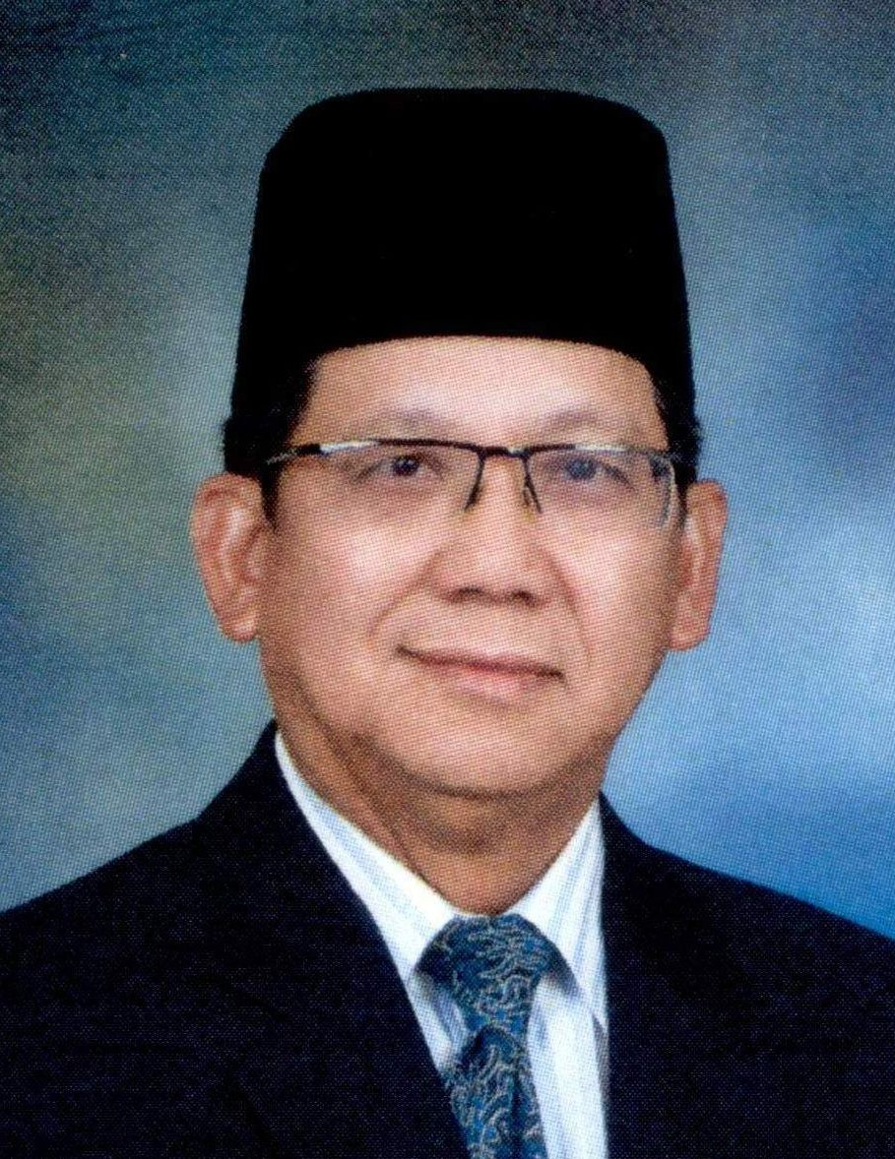
CURRICULUM VITAE
PEHIN ORANG KAYA INDERA PAHLAWAN
DATO SERI SETIA HAJI SUYOI BIN HAJI OSMAN
P.S.N.B., D.P.M.B., P.S.B., P.J.K., P.I.K.B., P.K.L.,
MINISTER OF EDUCATION
BRUNEI DARUSSALAM

ACADEMIC | : | 1986 - Masters in Public Policy (MIPP) School of Advanced International Studies (SAIS) John Hopkins University, Washington DC
 | : | 1976 - Post Graduate Certificate of Education (PGCE), Institute of Education, University of London
 | : | 1975 - University of East Anglia, Norwich, England in Development Studies
CAREER | : | Minister of Education, Ministry of Education
 | : | Minister of Development, Ministry of Development
 | : | Minister of Health, Ministry of Health
 | : | Deputy Minister of Education, Ministry of Education
 | : | Permanent Secretary, Ministry of Foreign Affairs
 | : | Director of Research Department, Ministry of Foreign Affairs
 | : | Ambassador to France
 | : | Deputy Permanent Representative, Permanent Mission of Brunei Darussalam, New York
 | : | Education Officer in 1976

COMMITTEES |  | Chairman, Board of Directors of Yayasan Sultan Haji Hassanal Bolkiah
 | : | Chairman, Board of Trustee for the Pengiran Muda Mahkota Al-Muhtadee Billah Fund for the Orphans
 | : | Deputy Chairman of the Autoriti Monetari Brunei Darussalam (AMBD)
 | : | Deputy Chairman of the University Brunei Darussalam Council
 | : | Co-Chairman of the Steering Committee for the Sultan’s Scholar Scheme of the Yayasan Sultan Haji Hassanal Bolkiah
 | : | A member of Supreme Council for Brunei Vision 2035 (Majlis Tertinggi Wawasan Brunei 2035)
 | : | A member of Higher Committee of National Development Plan (Jawatankuasa Tertinggi Rancangan Kemajuan Negara)
 | : | A member of Manpower Planning Council
AWARDS AND DECORATIONS | : | bestowed the title of Pehinship as “Pehin Orang Kaya Indera Pahlawan”
 | : | conferred Datoship which carries the title “Dato Seri Setia”
 | : | On the 7th December 2007 was conferred an Honorary Fellowship of the Faculty of Dentistry of The Royal College of Surgeons of Edinburgh, United Kingdom.
 | : | the 5th April 2008 was conferred an Honorary Fellowship by the Academy of Family Physicians of Malaysia

