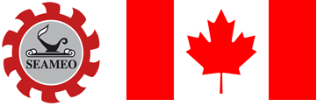

2021/2022 SEAMEO-Jasper Research Award

Theme:
Addressing the Education Crisis: Intervention Programmes for Mitigating Learning Gaps and Learning Loss

Application Form

Name:
 | Surname |  |  | First/Given |  |  |  |  |  |  | Middle (If any)
Nationality
Sex |  | ◻ Male |  |  |  |  |  | ◻ Female
Date of Birth
 |  | Date |  |  |  | Month |  |  |  |  |  |  | Year
Place of Birth
 |  | City/Province |  |  |  |  |  |  | Country
Mailing Address:
Office
Residence:
Telephone No:
 |  | Office (1) |  |  |  |  |  | Office (2)
 |  | Residence |  |  |  |  |  | Mobile
FAX:
E-mail Address:

Academic Background
Degree Obtained  (Major Field) | Institution | Year Attended (Inclusive)

Professional Background
Position/Designation | Agency/Institution | Years Employed (Inclusive)

Other Research and Publications (Completed over the past five years)

Please share your views on how your work as a researcher could be enhanced by winning the SEAMEO-Jasper Research Award

Date __________________________ Signature _________________________________________
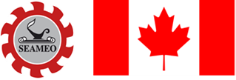

2021/2022 SEAMEO-Jasper Research Award

Theme: 'Addressing the Education Crisis:
Intervention Programmes for Mitigating Learning Gaps and Learning Loss

The Research Entry

Descriptive Title:

Research Team Members (Names, Institutions and nature of their participation):

Other prizes, awards or citations received
(please cite the year and award-giving body):

Date Started: _________________ Date Completed: __________________

Study Site(s)/Locale: _______________________________________________

Implementing Agency/Unit:

Funding Agency (if any):

Willingness to re-format the research entry into manuscript form for possible publication to SEAMEO Journal:

____________YES ____________ NO

If YES, SEAMEO Secretariat will provide you with SEAMEO Journal’s Guide for Authors.

Briefly discuss how the research project highlights the role of education/science/culture in facilitating or accelerating regional mobility in Southeast Asia.

Briefly discuss how the research project may contribute towards better understanding between Canada and Southeast Asia

Please send one set of electronic file of the following on or before 31 August 2021:
(i) Completed Application Form, (ii) 20-page Summary of the Research Paper, (iii) one-page Abstract of the Research Paper, and (iv) Complete Research Paper

To: 2021/2022 SEAMEO-Jasper Research Award
SEAMEO Secretariat
Mom Luang Pin Malakul Centenary Bldg
920 Sukhumvit Road
Bangkok 10110, Thailand
E-mail: seameojasper-research@seameo.org

