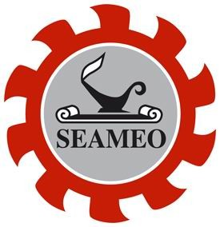
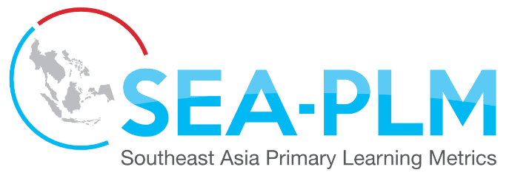
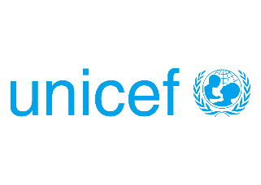

Press Release

Children from disadvantaged backgrounds in Southeast Asia doing worse in primary school than their peers
1 out of 3 children in Grade 5 is still performing at the level expected in
the early years of primary education

Bangkok, Tuesday, 1 December 2020: Data issued today from the Southeast Asia Primary Learning Metrics (SEA-PLM) – the first-ever student learning assessment created exclusively for the region –shows alarming inequities of learning for disadvantaged children in the region. For instance, across participating countries, 1 out of 3 children in Grade 5 is still performing at the level expected in the early years of primary education. This figure however hides that inequities in learning outcomes for children in some countries is alarming. SEA-PLM results show that the percentage of children able to do the basics in literacy and numeracy is as low as 2% in some countries.

This assessment, known as ‘SEA-PLM 2019’, measured learning outcomes for children enrolled in Grade 5 in six countries: Cambodia, Lao PDR, Malaysia, Myanmar, Philippines and Viet Nam. It provided countries with data to ensure a better understanding of children’s performance in reading, writing and mathematics. For the first time, global citizenship attitudes, values and behaviours of children were also measured by a large-scale learning assessment at primary education level.

SEA-PLM 2019 also reveals substantial differences in the number of children performing at the highest levels of expected learning. For instance, in some countries, a large majority (91%) of Grade 5 children are able to perform complex mathematical operations, while in others very few (8%) children are prepared for these tasks. This level of performance is equivalent to the minimum level of proficiency in international standards such as SDG 4.1 at the end of primary education. This shows that many countries are still far from reaching the agreed international goals.

SEA-PLM 2019 confirms persistent inequities, with children from wealthier backgrounds reaching higher levels of learning achievement, while those in the most deprived contexts suffer from a lack of high quality learning opportunities. Gender dynamics also play an important role in learning. Globally, girls are more likely to perform better than boys, regardless of socioeconomic status or school location, and this appears to hold true for the SEA-PLM 2019 results as well. Despite the difference in performance, in all countries, a large proportion of girls and boys in some countries still have difficulties reaching the expected level of performance in the three domains.

New data was collected on children’s attitudes, values and behaviours around “global citizenship”, a concept that includes community, societal, environmental and world affairs. On average, 90% of children think it is important to learn how to protect the environment and around 85% want to learn how to solve problems in their communities. On average, 70% of children agree they should be able to say what they think about their governments, and for all ethnic/racial groups to be treated equally. At the same time, less than half of the children participating in the study reported having some experience in speaking in an organized debate or a discussion about problems in the world.

The report also includes some encouraging findings. It found that in all countries, children who attended at least 1 year of preschool education consistently performed better than children who had not. On average, children who felt better and safer at school performed better than children who reported less positive feelings. In all countries, higher levels of parental engagement were associated with higher reading, writing and mathematics scores in children. This indicates that with the right policies and programmes in place at both the school and system level, a significant proportion of children can improve and reach higher proficiency levels.

SEA-PLM-2019 was jointly conducted by the Southeast Asian Ministers of Education Organization (SEAMEO) and UNICEF, with the technical support of the Australian Council for Educational Research (ACER). This assessment is part of the broader SEA-PLM programme, which aims to generate evidence for monitoring learning outcomes across and within ASEAN countries. It helps countries, practitioners and communities to identify, prioritize and address educational challenges in key policy areas, such as curriculum development, resource allocation, and pedagogical practice. SEA-PLM is aligned with the SDG 4 global agenda, and with SEAMEO and ASEAN Educational priorities.

“Addressing the learning gap for all children is a complex challenge as governments and communities won’t be able to apply immediately radical changes, but with strategic plans, policy commitments and support real changes can take place”, said Dr Ethel Valenzuela, Director of SEAMEO Secretariat.

“SEA-PLM 2019 enables countries in Southeast Asia to gain invaluable insights into where children are at in their learning. It will lay the foundations for policies and practices that will improve learning for all children, no matter their background, gender or ethnicity. ACER is proud to be involved in the first assessment of its kind in Southeast Asia and in a study that contributes to monitoring and reporting against SDG 4.1,” said Jeaniene Spink, Research Director of ACER's Education and Development research program.
“All children have the right to acquire foundational learning and the skills to understand the world and engage in their communities. SEA-PLM 2019 tells us what children actually know and can do. It also tells us what children think and value. This is an extraordinary tool. We must use it to bridge the learning and equity gaps. The current COVID-19 pandemic forces all of us to re-imagine the education systems. It is our collective responsibility to do this with robust data and with a clear focus to improve equity in learning”, said Francisco Benavides, Regional Education Adviser, UNICEF Regional Office, East Asia and Pacific.
The report concludes with a set of six policy recommendations focused on improving school support, teacher education and policies, and increasing the alignment of curriculum, assessment and pedagogies. Strongly recommended in the report is an increase in access to early learning, particularly for the most disadvantaged children. SEA-PLM 2019 demonstrates that when children attend early learning programmes, the positive influence continues to show in children’s learning outcomes at least five years into their primary education and puts them ahead of their peers that do not.
The other recommendations focus on improving the capacity of governments to use data and to effectively monitor learning so that they can better understand where children are at in their learning. It also encourages the use of SEA-PLM 2019’s rich data sets; and invites all countries in Southeast Asia to join SEA-PLM 2023’s new cycle. The recommendations are:
- Prioritize early learning in disadvantaged contexts
- Guarantee a solid start in primary education through on-time enrolment and progression for all children, especially the disadvantaged.
- Ensure explicit and progressive learning standards in the curriculum of basic education, including in digital and blended learning options
- Support motivated and experienced teachers and positive school environments
- Use data, monitoring and research to achieve better learning
- Participate in, and support SEA-PLM 2023 activities, including opportunities and challenges arising from the COVID-19 pandemic

-Ends-

Notes to Editors:

Link to SEA PLM webpage:
https://www.seaplm.org/
Link to the report:
https://www.seaplm.org/index.php?option=com_content&view=article&id=44&Itemid=332

For further information, please contact:

- SEA-PLM Secretariat: seaplm@seameo.org

- ACER Communications, M: +61 (0)419 340 058, communications@acer.org

- SEAMEO Secretariat, Ms Piyapa: +66 (0) 2391-0144, 2391-0256, 2391-0554, secretariat@seameo.org; piyapa@seameo.org

- UNICEF, Shima Islam, Regional Communication Specialist, Tel: +66 (0) 2 356 9407, ssislam@unicef.org

