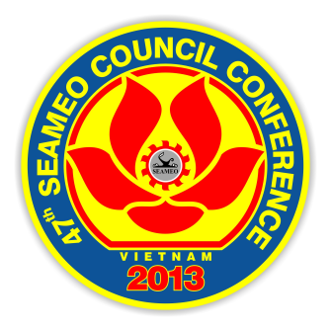

Please affix a recent passport photo here or email it to:

seamec47@gmail.com;
cc to: secretariat@seameo.org

(me 72dpi)

Venue: Hanoi Daewoo Hotel
360 Kim Ma Street, Ba Dinh
Hanoi, Vietnam

Annex B: REGISTRATION

Name (Dr/ Mr/ Ms) : _________________________________________________________

Preferred Postal Address : ___________________________________________________

___________________________________________________
Work Contact Details:

Designation : _________________________________________________________

Organisation : _________________________________________________________

Suburban/Town : _______________________ Zip/Postcode______________________

Country : _________________________________________________________

Office Phone/Fax : _________________________________________________________

Email Address : _________________________________________________________

Categories:

Member Country Associate Member Affiliate Member SEAMEO Centre

Observer Others (please specify) _______________________________

ACCOMMODATION:

Hotel bookings required: Yes No

*Please refer to the Conference Information and Guidelines for details of hotel options.

Please tick | Name of Hotel | Room Type | If you wish to share room with another participant, please write the name

Flight Schedule:

1. Arrive at Noi Bai International Airport (Hanoi) on: [Date] _________ [Arrival Time] _____________
[Flight Number] __________________ [From] _________________________________________

2. Depart from Noi Bai International Airport (Hanoi) on: [Date] _______ [Arrival Time] _____________
[Flight Number] __________________ [To] ___________________________________________

Transportation will be provided to and from the Noi Bai International Airport (Hanoi).

Special dietary requirements:

………………………………………………………………………………………………………..
__________________________________________________________________________

CULTURAL VISIT

Kindly indicate your interest by ticking the box below:

Please tick | Cultural Visit
 | Visit within Hanoi: 1415–1800 hrs Thursday 21 March 2013
 | Visit to Ha long Bay: from 1530 hrs Thursday afternoon (21 March) to Friday afternoon (22 March 2013)

Please return completed form to:

The SECRETARIAT
47th SEAMEO Council Conference
Ministry of Education and Training of Vietnam

Fax: +84 4 3 8693243
Email: seamec47@gmail.com
Cc: secretariat@seameo.org

