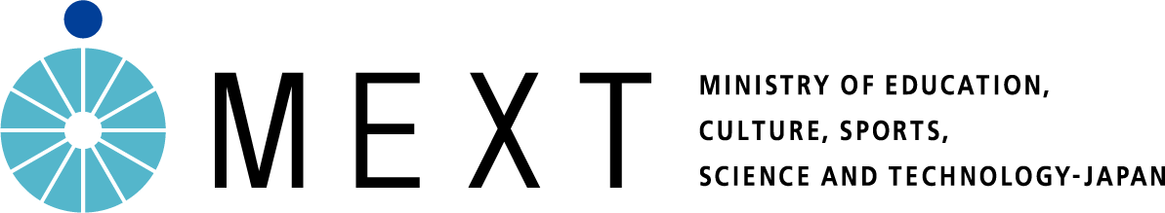
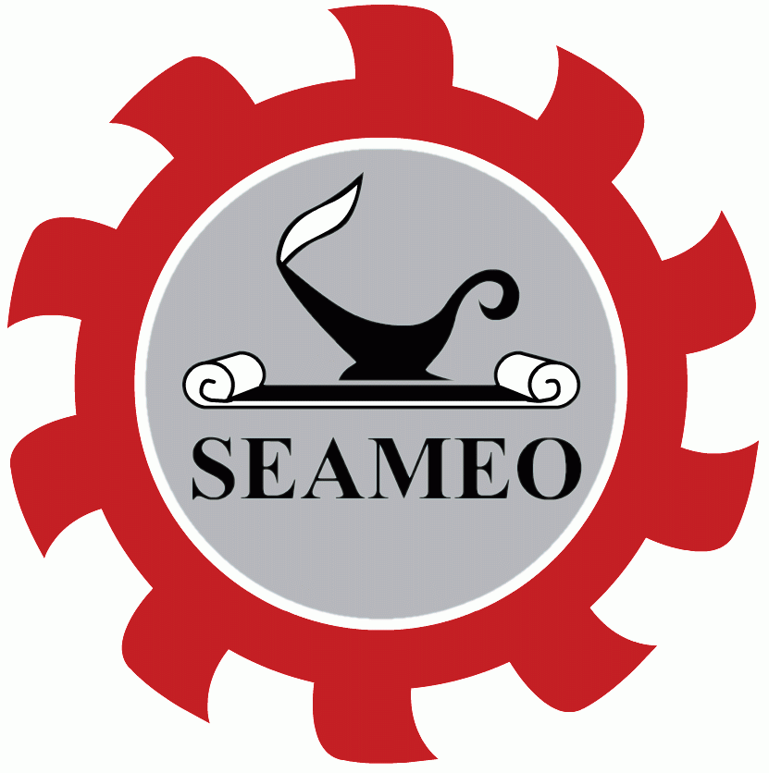
SEAMEO-Japan ESD Award

Supporting Partner:
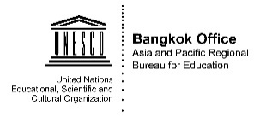

Submission Form of 2019 SEAMEO-Japan ESD Award
Theme: Building Peace in Schools and Communities

The last day for submission of entries: 16 September 2019 (extension)

- To participate in the 2019 SEAMEO-Japan ESD Award, please submit the information of your school’s project/programme on “Building Peace in Schools and Communities” by using this Submission Form by Monday 16 September 2019.
- The digital format of this Submission Form can be downloaded from the following link/QR Code or requested by sending an email to: seameojapan.award@seameo.org.

http://bit.ly/2019SEAMEOJapanESDAward
- The guidelines for submission of entries and the judging criteria are detailed in page 9-12 of this document.
- How to Submit the Entry: Schools can submit the completed "Submission Form of 2019 SEAMEO-Japan ESD Award" and maximum of 5 supporting documents/materials to the SEAMEO Secretariat by

Option 1: By Google Link (Teacher should have a gmail email account.)
Submitting the application and 5 supporting documents to the following GOOGLE LINK:
http://bit.ly/2019ESDAward-submission

If the school has difficulties in submitting the entry and documents to the above google link, please email to: seameojapan.award@seameo.org

Option 2: By Email
Submitting the completed “Submission Form of 2019 SEAMEO-Japan ESD Award" and maximum of 5 supporting documents to the SEAMEO Secretariat by email:
seameojapan.award@seameo.org

- Important Note: To align with the ESD practices and to save the environment and energy, the Committee will not accept the entry in hard copies.
- More information, please contact the SEAMEO Secretariat, Bangkok: Tel. +66-2391-0144, Email: seameojapan.award@seameo.org.

PART I: Details of Your School
- Name of your school: ……………………………………………………………………………
- Full address: …………….…………….…………….…………….…………….…………….…
……………….…………….…………….…………….…………….…………….…………….
- Postcode: ………………… 4. Country: …………
- School’s telephone number (country code+city code+telephone number): ………….
- School’s fax number (country code+city code+fax number): ………………
- School’s email Address: …………….
- Name of the Head Master/Principal/School Director: ……………
- Name of the Teacher Coordinator: ………..
- Email address of the Coordinator: …………..
- School website (if available): …………….
- Educational level (Such as Kindergarten 1 to Grade/Year 9): ……………
- Total number of teachers in your school: …………
- Approximately number of teachers participated in this programme: ……….
- Total number of students in your school: ……….
- Approximate number of students participated in this programme: ……….

PART II: Information about the School’s Programme

The information of part II from no.1 to 13 should be no longer than nine (9) pages long of A4 in total. The information should be written in Times New Roman font, 11-12 point size.

- Title of the school’s programme

- Summary of the programme (one half to 1 page of A4 sheet size)

- Background information or reasons why the school created this programme

- Objectives/goals of the programme

- Period of the time when the programme was/has been started

- Key knowledge, skills, attitudes/values and behaviors that you expect develop from this programme.

- Activities (Strategies, activities, steps for implementation)
This part is important – please clearly explain all related strategies and activities that the school has implemented and breir information of each strategy/activity). Details of each activity can be attached as a part of supporting documents.

- Teaching and learning approaches/strategies that the school has integrated for peace education.

- A) Participation with the community (How the school and community work together in planning and implementing the school programme)

- Engagement of partners in community and their roles/contribution (Please provide the name of your partners in this programme and their roles/contributions)

Name of Partners | Roles and Contributions
(Please add more row if it is necessary)

- Activities that the school, students and teachers have contributed to the community

- Programme for monitoring and evaluation mechanisms and summary of results

Monitoring and evaluation mechanisms:

Summary of results:

- Resources used for programme implementation

- Benefits/Impacts/ positive outcomes of the programme to students, school and the wider community

- Interrelationship of the school programme with other Sustainable Development Goals (SDGs)
(Please refer to page 2 in the Information Note or https://sustainabledevelopment.un.org/sdgs)

- Plan for sustainability and plan for scaling-up/expansion

Plan for sustainability:

Pan for scaling-up/expansion:

- Achievements from the school’s programme “Building Peace in Schools and Communities”

- List of supporting documents such as a copy of the school operational plan or school management plan, action plan, learning/ teaching materials, lesson plans, samples of student worksheet, manuals, etc.

If the supporting documents are in the local language, please provide a brief description in English language.

A maximum of 5 Supporting Documents are required can be submitted to the provided google link.

Document 1) (File name)……….
Document 2) ……………..
Document 3) ……………..
Document 4) …………….
Document 5) …………….

- Photos related to the activity/programme (Maximum of 5 photos with captions in English)

Photo1

(Caption in English)

Photo 2

(Caption in English)

Photo 3

(Caption in English)

Photo 4

(Caption in English)

Photo 5

(Caption in English)

Guidelines for Submission of Entries

- Schools can submit information about the school’s programme/project/activity related to the theme “Building Peace in Schools and Communities” from 10 June to 16 September 2019 (extension).
- The deadline of entry submissions is Monday, 16 September 2019. (Late submission will not be accepted.)
- Each school can submit only one entry.
- The submission of the school’s programme must be done through the template “Submission Form of 2019 SEAMEO-Japan ESD Award”.
The Submission Form can be downloaded from the SEAMEO website: http://bit.ly/2019SEAMEOJapanESDAward
or requested by sending an email to the email address: seameojapan.award@seameo.org.
- Regarding the submission of entry, each school must adhere to the following format, as specified in the Submission Form:
- Part I - Information about the school;
- School name and contact details
- Brief information about the school such as number of teachers and students and educational level
- Contact details of the coordinator
- Part II - Information about the school’s programme;
- Title of the school’s programme
- Summary of the programme (one half-page of A4 sheet size)
- Background information or reasons why the school created the programme
- Objectives/goals of the programme
- Period of time when the programme was/has been started
- Key knowledge, skills, attitudes/values, and behaviors that you expect to develop from this programme
- Activities (Strategies, activities, or steps for implementation)
- Teaching and learning approaches/strategies that the school has integrated for peace education
- Participation with the community/roles of community
- Activities that the school, students, and teachers have contributed to the community
- Programme for monitoring and evaluation mechanisms and summary of results
- Resources used for programme implementation
- Benefits/impacts/positive outcomes of the programme to students, school and the wider community
- Interrelationship of the school programme with other Sustainable Development Goals (SDGs)
- Plan for sustainability and plan for scaling-up/expansion
- Achievements from the school’s programme “Building Peace in Schools and Communities”
- List of attachments such as a copy of the school operational plan, action plan, learning/teaching materials, lesson plans, samples of student worksheet, manuals, etc.
- Photographs related to the school programme (maximum of five photographs with captions written in English)
- Information about the programme (Part II as above) should not be over nine (9) pages of A4 in total. The information should be written in Times New Roman font, 11-12 point size. (A half-to-one page A4 sheet size about the project overview should be included.)
- Information about the programme and the photo captions must be in English. The teaching and learning materials can be in local languages, however a brief translation in English should be provided.
- All submissions should include related photos. (A maximum of five (5) photographs with captions written in English.)
- All submissions can be attached with a maximum of five (5) supporting documents (Optional).
- How to Submit the Entry: Schools can submit the completed "Submission Form of 2019 SEAMEO-Japan ESD Award" and maximum of 5 supporting documents/materials to the SEAMEO Secretariat by 2 options:

Option 1: By Google Link (Teachers should have a gmail email account.)
Submitting the application and 5 supporting documents to the following GOOGLE LINK:
http://bit.ly/2019ESDAward-submission

If the school has difficulties in submitting the entry and documents to the above google link, please email to: seameojapan.award@seameo.org

Option 2: By Email
Submitting the completed “Submission Form of 2019 SEAMEO-Japan ESD Award" and maximum of 5 supporting documents to the SEAMEO Secretariat by email.

Email: seameojapan.award@seameo.org

Note: To align with the ESD practices and to save the environment and energy, the Committee will not accept the entry in hard copies.

- All entries submitted to the SEAMEO Secretariat will be acknowledged. If the school has not received any acknowledgement of the receipt from the SEAMEO Secretariat within one week after the submission, please contact the SEAMEO Secretariat (Email: seameojapan.award@seameo.org).

Judging Criteria

The judging committee will consider the following criteria in selecting the winning schools:

- Integration of Strategies/ Modalities for Implementation
- Implementation of peace education is emphasized and incorporated into school policies, management plans, and teaching and learning programmes within the school.
- The school has demonstrated clear effective strategies, steps, and activities in applying peace education for building the culture of peace in school and communities.
- The school has demonstrated the use of participatory processes – involving students, teachers, parents, communities’ stakeholders and partners – in planning and implementing the programmes.
- Appropriate and effective methods and resources are used to implement the programmes.
- Monitoring and evaluation mechanisms or processes are identified to ensure the immediate and long-term outcomes of the programmes.

- Innovation and Creativity
- The school’s programme has demonstrated innovative practices in promoting culture of peace in the school and communities.
- The school’s programme has demonstrated innovative practices in integrating peace education and current education system.
- The school has demonstrated innovative ideas for utilising available resources.
- The entry is a new idea or an improved/adapted version of existing activities.

- Teaching and Learning Approaches
- The school has demonstrated effective teaching and learning approaches that have been applied to improve the culture of peace in its school and community environment.
- The school has embedded the proper knowledge, skills, attitudes, values, behaviors and daily practices into subject disciplines and incorporated ESD principles and pedagogical methods to ensure that students are able to connect the practices in their daily life, and community.
- The teaching and learning approaches has demonstrated the change or transformation of attitudes, values, and behaviors of students and teachers.

- Engagement of Community
- The school has engaged community-level partners such as community stakeholders, experts, cultural bearers, elders, local leaders, practitioners and parents who provide information and guidance on peace education.
- The school has engaged multi-sector partners such as education institutions, teacher-training institutions, schools, cultural institutions and professional associations to co-implement the school’s programme.
- The school’s programme has strengthened students’ involvement in the local community, especially for peace building.
- Through the school’s programme, the school has engaged and contributed to the development of local community, not just only parents.

- Sustainability
- The school has promoted peace education within the school management plan and teaching and learning activities across subjects for a long-term action strategy.
- The school has demonstrated a clear future plan on how to sustain the programme.

- Interrelationship with other Sustainable Development Goals (SDGs)
- The school has demonstrated that the school’s programme has integrated the improvement of other SDGs, not the individual pursuit of each SDG, but has interrelation with other SDGs. – Therefore, the school should make a clear statement in its application on how the school’s programme connects with other SDGs apart from SDGs 10 (Reduce Inequalities) and SDGs 16 (Peace, Justice and Strong Institutions) a.

- Impacts
- Results, during/after implementation, have revealed the effectiveness and benefits of the school’s programme to students, teachers, parents and the wider communities.
- Information, data, and model collection about peace education has been effectively compiled, documented, and shared within the schools, among schools in one community, and at the broader provincial or national levels.

Contact Information

For enquiry, please contact:
SEAMEO-Japan ESD Award
SEAMEO Secretariat
920 Sukhumvit Road
Klongtoey, Bangkok 10110
THAILAND
Email: seameojapan.award@seameo.org
Website: www.seameo.org
Tel: +66-2391-0144
Fax: +66-2381-2587

